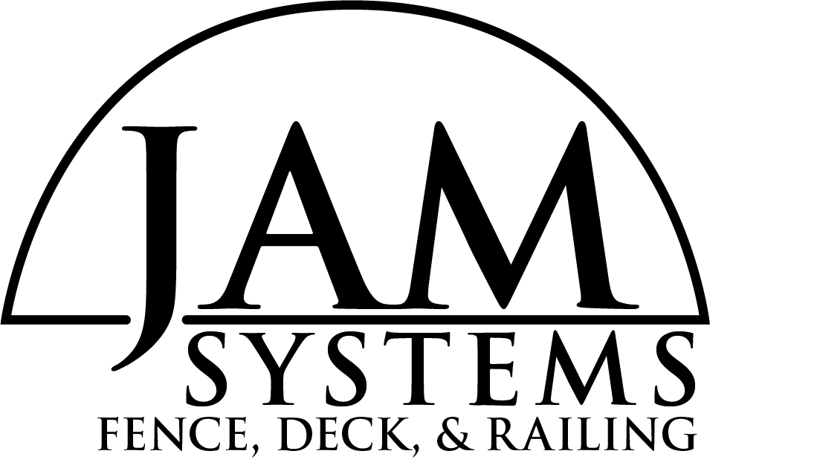
Thank you for your interest in our company. JAM Systems’ manufacturing facility is located in Dyersville, Iowa. We have a state of the art facility that allows us to produce the following high quality products price competitively and efficiently.
Our products include:

- NEW Advantage Aluminum Railing
- Vertical & Horizontal Cable Railing in Aluminum

- Vinyl Railing
- Vinyl Fence
- Vinyl Pergolas
- Plus endless special order capabilities

We have been serving our customers with high quality products and a very high level of service for close to 30 years.
All of JAM Systems’ products carry a Limited Lifetime Transferable Warranty, including a fade statement.
What separates us from our competition is Service and Quality. We offer the following services:
- We do your take-offs and quote you back in 1/2 day.
- Most orders ship in 48 hours.
- Contractor / Customer trainers
- Job site assistance
- Unparalleled customer service;
- Behind our “800 number ”is a full technical support staff team that is here to:
- Answer all your questions on products and installation.
- Do your take-offs and get you a material lists for quotes in a timely matter.

JAM Systems would be honored to add you as a customer!

